**An Enhanced Feature Based Classification Model for Plant Diseases Detection Using CNN Technique**

***Amit Vermaa,c, Shweta Chauhana,b,c***

*aDepartment of Computer Science and Engineering,*

*bApex Institute of Technology,*

*cUniversity Centre for Research & Development,*

*Chandigarh University, Gharuan, Mohali, Punjab, India, 140413,*

*(amit.e9679@cumail.in, shwetachauhansc.2000@gmail.com)*

***Abstract***

***The agriculture industry is vital to maintaining global food security, prompt and precise plant disease detection is critical to crop protection and yield optimization. Conventional techniques for diagnosing diseases frequently depend on skilled professionals' subjective and time-consuming visual assessment. Deep learning methods have become effective instruments for automating plant disease identification and diagnosis in recent years, with the promise for quick and accurate evaluation.***

***The capacity of the suggested convolutional neural network (CNN)-based model to detect plant diseases to capture complex patterns and temporal relationships in a variety of plant datasets is critically analysed.***

**1. INTRODUCTION**

India is the land of agriculture where crop production plays a significant role in the agriculture industry and the country's economy [2]. Crop production is facing issues widespread in India. Leaf plays an essential function in crops because it provides information about the quantity and quality of agricultural production [3]. Crop disease is one of the most important factors influencing on it. Leaf spot diseases damage trees and shrubs by interfering with photosynthesis, the process through which plants produce energy that fuels their development and defensive systems, as well as influencing their survival. The production is decrease day by day due to a variety of causes, i.e., being plant illnesses that go undetected for long periods of time.

Artificial Intelligence in agriculture not only helping farmers to automate their farming but also shifts to precise cultivation for higher crop yield and better quality while using fewer resources. Researchers involved in improving machine learning / Artificial Intelligence-based products or services for training data for agriculture, drone, and automated machine making will get technological advancement to provide more practical applications. These applications are helping the world deal with food production issues for the future growing population. The article will help researchers explore different avenues regarding automation techniques, applying them to tackle other agricultural issues, including classification, prediction of the various diseases of crops, and computer vision and image analysis. The general advantages of profound learning empower its further use towards more intelligent, more supportable cultivating, and safer food creation. The automatic frameworks presented in current literature can be fabricated, giving early warning of diseases of the crops. A mix of picture handling and AI methods can offer specialists the freedom to address issues in different areas that affect society directly.

**1.1. Automation techniques categorization**

The utilization of Artificial Intelligence (AI) in agriculture will be enabled by various technological advances, including big data analytics, computer vision, the internet of things, robotics, drone technology, the availability of cheap cameras and sensors, and even wide-scale internet coverage on geographically dispersed fields [2]. Among the accessible instruments of Artificial Technology, we feature Computer Vision arrangements that accomplished significant outcomes in recognizing plant diseases using pictures. To meet the growing demand for fast and accurate methods in monitoring grain production, the use of computer vision has grown in recent years [5]. The usage of automation techniques in the agriculture field is increasing exponentially. These automation techniques affect the crop yield in a positive manner, which indirectly affects the economy of any country. The application of AI techniques in the agriculture processes, as discussed in the above sections, is a hot topic in the research field also [43]. The most popular applications of AI techniques in the agriculture processes mainly fall into three categories discussed below:

* Agriculture Robots: Companies were developing and programmed autonomous robots which handle the essential tasks, which include harvesting, weed control, sowing at a higher volume and faster pace than humans do, e.g., Blue River technology used for weed control, CROO Robots for crop harvesting.
* Crop and Soil Monitoring: In this field, the data captured by the drones, sensors, or software is processed using AI techniques which can help the farmers during crop monitoring or other effects of soil on crop yield, e.g., PEAT, TRACE Genomics uses machine learning for diagnosing the soil defects.
* Predictive Analysis: The effect of the environment affects the crop yield in different manners. In this area, other learning models are used to track and predict various environmental impacts on the crop yield, e.g., where satellites are used to monitor the weather conditions, crop health & sustainability.

**1.2. Computer Vision: Definition**

Computer vision is a logical interdisciplinary field that manages how Computers can acquire a significant understanding of computerized images or recordings. From the perspective of designing, it tries to comprehend and computerize assignments that the human visual framework can do [44]. Figure 1 shows the generalized approach of the computer vision techniques for precision agriculture.

**Figure 1. Generalized steps for Computer vision techniques for the classification of the images**

**2. LITERATURE SURVEY**

As per Broadus (1987), bibliometrics is a research field that quantitatively considers bibliographic material, which provides an overall outline of an exploration field according to a broad scope of markers (citations, h-index, publications, and so forth) [6].

The data for the bibliographic study is taken from the Scopus database using different filters described in this section. The number of publications published in the Scopus database from the year 1991 to 2023 is assumed. Two keywords are used for the searching process using AND, i.e., “Computer Vision” AND “Crop Management”. The total number of documents retrieved is 312 using the above-said filters from the Scopus database. The “VOS viewer software package” is used for the bibliometric analysis is done on different parameters of the documents published from 1991 to 2023 in SCOPUS.

**Table 1. Year-on-year basis trends of the number of publications and cumulative publications.**

|  |  |  |
| --- | --- | --- |
| **Year** | **No. of publications** | **Cumulative Publications** |
| 1991 | 1 | 1 |
| 1994 | 1 | 2 |
| 1996 | 2 | 4 |
| 1997 | 1 | 5 |
| 1998 | 1 | 6 |
| 1999 | 2 | 8 |
| 2000 | 1 | 9 |
| 2002 | 1 | 10 |
| 2003 | 2 | 12 |
| 2004 | 3 | 15 |
| 2005 | 3 | 18 |
| 2006 | 2 | 20 |
| 2007 | 6 | 26 |
| 2008 | 7 | 33 |
| 2009 | 2 | 35 |
| 2010 | 5 | 40 |
| 2011 | 10 | 50 |
| 2012 | 4 | 54 |
| 2013 | 2 | 56 |
| 2014 | 10 | 66 |
| 2015 | 7 | 73 |
| 2016 | 17 | 90 |
| 2017 | 16 | 106 |
| 2018 | 16 | 122 |
| 2019 | 13 | 135 |
| 2020 | 43 | 178 |
| 2021 | 46 | 224 |
| 2022 | 60 | 284 |
| 2023 | 28 | 312 |

The number of publications is increasing every year, as shown in Table 1, this indicates that automation technologies in the agriculture field are growing with time. For making the agriculture processes more efficient, automation techniques are increasing, and the said field innovations are also growing [45]. Computer vision technology is used in the early stages of crop harvesting to detect plant diseases early.

**Figure 2. The number of documents, citations on countries.**

The figure 2 shows the publications of the specific country, the citations of the country's documents, and the link strength graphically. The graph is drawn using the data retrieved from the Scopus database, which shows the highest number of papers published by the United States followed by China, India, and so on. The citations of the documents of the United States are also higher than any other country, followed by Brazil, Japan, Spain, and so on.

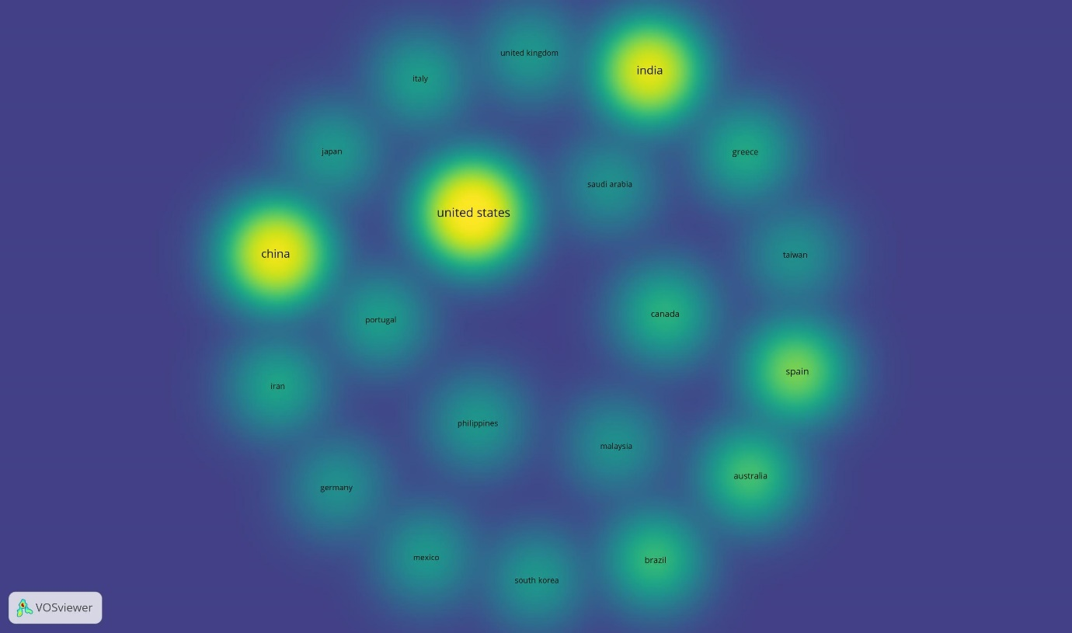

**Figure 3. The number of publications, citations, and link strength on countries were obtained using the VOSviewer tool.**

The figure 3 is retrieved using the Vosviewer software and Scopus data, in which pictorially the role of the different countries as mentioned in the above table. The size of the bubble shows the role of that countries, as shown in Figure 7 that the United States has the highest number of publications.

**2.1. Occurrences of the keywords related to Computer Vision**

In our study using the Scopus database, the main categories we differentiated from the data using Vosviewer Software Tool are Computer Vision, Deep Learning, Machine Learning & Agriculture Robots. The said terms are retrieved from the data and how their occurrences affect the research areas.

**Figure 4. The occurrences of the terms we categorized in the data retrieved from SCOPUS.**

The above figure describes the technology of the computer vision used as the application of AI I technology in agriculture lead concerning the other technology as per the data retrieved from the Scopus database. The second technology after computer vision is image processing, followed by deep learning, agricultural robots, and machine learning. The exact figure of the occurrences of the categories are mentioned in the table below

**Table 2. Technologies and their occurrences in the database retrieved from SCOPUS.**

|  |  |  |
| --- | --- | --- |
| **S.No.** | **Keyword** | **Occurrences** |
| 1 | Computer Vision | 109 |
| 2 | Image Processing | 43 |
| 3 | Deep Learning | 22 |
| 4 | Agricultural Robots | 13 |
| 5 | Machine Learning | 13 |

The categories we mentioned in the above figure and table show that computer vision leads the used technology. There is a scope of work in the research field in machine learning technology. It becomes even more apparent from the figure below, retrieved using the VOS viewer Software Tool, and gives the exact idea of the research scope in the above-said field.



**Figure 5. Cloud density of the technologies used in research articles.**

**3. METHODOLOGY**

Image Acquisition is the first process is to retrieve the image from the available sources which is called as Image Acquisition. Image acquisition for the required purpose depends upon the dataset we are using for the plant diseases. The image acquisition can be done for two phases two phases i.e., Training of the model & Testing of the model. For training of the model, the image is taken from the authentic dataset used. And for testing, either take image from camera or select from gallery on which pre-processing is done and later on algorithm test that particular image.

Dataset Description: The datasets which are available free on KAGGLE, IMAGENET or other authentic and free sources can be used for the training and testing of the purpose of the developed AI model.

**3.1. Image Pre-Processing**

Before passing the image to the algorithm for testing and training, it should be pre-processed. For that reason, the image has been reduced to certain ratio say n by n pixels. The color conversion techniques can also be applied for the pre-processing process. The pre-processing techniques gives the appropriate image that can be used for further processing in the model and the retrieved pre-processed image can be passed through the model for training and testing purposes of the model.

**3.2. Image passed through the Developed Model for Processing**

The pre-processing of the image is followed by the training of the model in which the processed images are passed through the developed model for the training of the model. Model using the techniques of AI are used and the model and after the training process, the resultant model is called Trained model. The classification of the images is done using the trained model by which the diseases of the plant are classified. The figure below shows the chronology of the research approach in which the example of CNN Model is taken and this CNN model is trained using the images from the dataset. Every image from the dataset is firstly pre-processed and then used to train the model. After training process is completed, the model is ready for the second process called validation. Plant diseases detection using AI involves the application of various machine learning and computer vision techniques to identify and classify diseases affecting plants. Here is an overview of the process:

1. Data collection: Gather a large dataset of plant images that contain healthy plants as well as various diseased plants. The dataset should cover different plant species and a wide range of diseases to ensure robustness and generalization.
2. Data pre-processing: Pre-process the collected images by resizing them to a consistent size, normalizing the pixel values, and potentially applying other transformations like cropping, rotation, or flipping. This step helps to enhance the quality of the input data and remove any noise or artifacts.
3. Training a deep learning model: Utilize a deep learning model, such as a Convolutional Neural Network (CNN), to learn the patterns and features indicative of various plant diseases. The model is trained using the pre-processed dataset, where it learns to associate image characteristics with specific disease classes.
4. Validation and fine-tuning: Split the dataset into training and validation sets to evaluate the model's performance. Adjust the model's hyperparameters, such as learning rate, batch size, or network architecture, through techniques like cross-validation or grid search. This step helps optimize the model's accuracy and generalization capabilities.
5. Testing and evaluation: Evaluate the trained model on a separate test set to assess its performance. Calculate metrics like accuracy, precision, recall, and F1-score to measure how well the model can classify healthy and diseased plants. Consider using confusion matrices to analyse the performance across different disease classes.
6. Deployment and inference: Once the model demonstrate satisfactory performance, it can be deployed for real-time or near real-time inference. Develop an application or system where users can upload images of plant leaves or affected parts. The AI model analyses the images and provides predictions about the presence or absence of diseases.
7. Continual improvement: Maintain a feedback loop with users to collect their input and improve the model over time. Incorporate user feedback and new data into the training pipeline periodically to update and fine-tune the model, ensuring its adaptability to emerging diseases or variations in the environment.

It's important to note that the success of plant disease detection using AI relies heavily on the availability of high-quality datasets, the selection of appropriate deep learning architectures, and the continuous improvement of the model through iterative training and validation processes.

**4. EXPERIMENTAL RESULTS**

Image Acquisition is the first process is to retrieve the image from the available sources which is called as Image Acquisition. Image acquisition for the required purpose depends upon the dataset we are using for the plant diseases. The image acquisition can be done for two phases two phases i.e., Training of the model & Testing of the model. For training of the model, the image is taken from the authentic dataset used. And for testing, either take image from camera or select from gallery on which pre-processing is done and later on algorithm test that particular image.

Dataset Description: The datasets which are available free on KAGGLE, IMAGENET or other authentic and free sources can be used for the training and testing of the purpose of the developed AI model. There are 38 classes in the different datasets which is divided into train and validate dataset. There are lakhs of images that are available for these 38 classes of the plants on the above-mentioned datasets which includes diseased as well as healthy plant leaves. Train and validate sets have 38 classes.

**4.1. Image Pre-Processing**

Before passing the image to the algorithm for testing and training, it should be pre-processed. For that reason, the image has been reduced to certain ratio say n by n pixels. The colour conversion techniques can also be applied for the pre-processing process. The pre-processing techniques gives the appropriate image that can be used for further processing in the model and the retrieved pre-processed image can be passed through the model for training and testing purposes of the model.

Below are the different steps to be implemented in the image pre-processing:

* rescale: adjust the pixel values between 1 and 255.
* flow_from_directory: this function reads pictures out of folders and large numpy arrays.
* batch_size: The number of photos that each batch will receive from the generator.
* the supplied picture size, target_size, determines how big each image will be enlarged to: 128*128. Because there are 39 classes, class_mode is set to categorical.
* seed: A random seed that is used to shuffle the image's order and apply random image augmentation.
* shuffle: Select True to shuffle the sequence in which the image is supplied; select False otherwise.

Then in the next stage code is implemented to check whether any unsupported images are present the dataset, if the folder contains noisy images, it will stop executing there only. So, it will show the path you need to go there and delete that image note for validate set also.

**4.2. Image passed through the Developed Model for Processing**

The pre-processing of the image is followed by the training of the model in which the processed images are passed through the developed model for the training of the model. Model using the techniques of AI are used and the model and after the training process, the resultant model is called Trained model. The classification of the images is done using the trained model by which the diseases of the plant are classified. The figure below shows the chronology of the research approach in which the example of CNN Model is taken and this CNN model is trained using the images from the dataset. Every image from the dataset is firstly pre-processed and then used to train the model. After training process is completed, the model is ready for the second process called validation.

The below are the steps of the proposed CNN model with 4 convolutions where it is training with 39 classes and running with 50 epochs and learning rate is 0.001. The below figure gives the generalized view of the proposed model which is trained and validated using the data described above.

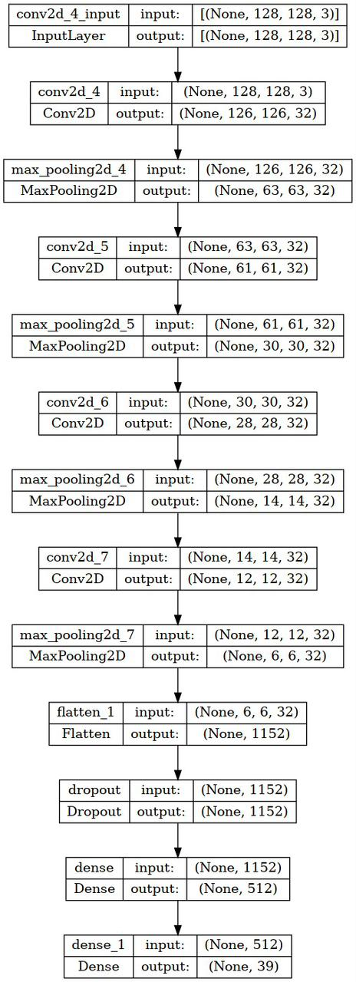

**Figure 7. Steps of the proposed model using CNN Technique**

**4.3. Visualizing Accuracy and Loss Values**

For visualizes the accuracy and loss values of the model trained using the data, below is the implementation technique, which gives the accuracy and loss values of the mode in a graph. For the data visualization, widely used package in Python is MATPLOTLIB and for describing the elements of the graph, a function called legend () is used to place the legend on the axes.

Below are the two graphs obtained after the implementation of the above code. The two graphs show the accuracy and loss values of the model trained and validated.

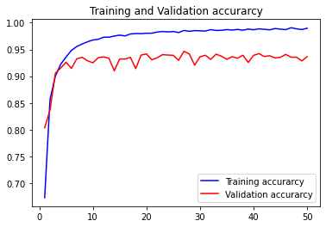

**Figure 7. Accuracy of the model after training and validation of the data**

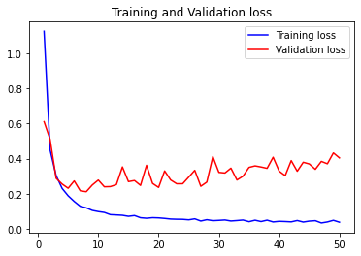

**Figure 8. Loss of the model after training and validation of the data**

The training accuracy and validation accuracy of the trained and validated model can be calculated using the len() function as follows:

# Training Accuracy

y=len(acc)

n=sum(acc)

print("Train Accuracy")

print(n/y)

#validation Accuracy

x=len(acc)

m=sum(val_acc)

print("Validation Accuracy")

print(m/x)

After execution of the above functions the obtained training and validation accuracy of the model are:

Train Accuracy: 0.968598234653473

Validation Accuracy: 0.9282497251033783

**5. CONCLUSION**

In conclusion, the use of a Convolutional Neural Network (CNN) model for plant disease detection holds significant potential in revolutionizing the agricultural industry. By leveraging the power of deep learning and image recognition techniques, CNN models can accurately and efficiently identify various diseases affecting plants, leading to early detection, prevention, and effective crop management.

In summary, the utilization of CNN models for plant disease detection represents a significant advancement in agriculture. With their ability to accurately identify diseases, these models can assist farmers and plant pathologists in making informed decisions for disease management, contributing to improved crop yields, reduced losses, and more sustainable agricultural practices. As further research and technological advancements continue, CNN models have the potential to play a pivotal role in transforming the way plant diseases are diagnosed and managed worldwide.

**REFERENCES**

[1] S. Phadikar, “Classification of Rice Leaf Diseases Based onMorphological Changes,” *Int. J. Inf. Electron. Eng.*, vol. 2, no. 3, pp. 460–463, 2012, doi: 10.7763/ijiee.2012.v2.137.

[2] M. Mukherjee, T. Pal, and D. Samanta, “Damaged Paddy Leaf Detection Using Image Processing,” *J. Glob. Res. Comput. Sci.*, vol. 3, no. 10, pp. 2010–2013, 2012, doi: 10.1016/j.proeng.2012.06.377.

[3] K. Venugoban and A. Ramanan, “Image Classification of Paddy Field Insect Pests Using Gradient-Based Features,” vol. 4, no. 1, 2014, doi: 10.7763/IJMLC.2014.V4.376.

[4] A. Kumar Singh and Bs. Raja, “Classification of Rice Disease Using Digital Image Processing and Svm Classifier,” *Int. J. Electr. Electron. Eng. ISSN*, vol. 07, no. 01, pp. 294–299, 2015.

[5] R. Islam, “An Image Processing Technique to Calculate Percentage of Disease Affected Pixels of Paddy Leaf An Image Processing Technique to Calculate Percentage of Disease Affected Pixels of Paddy Leaf,” no. August 2015, 2021, doi: 10.5120/ijca2015905495.

[6] C. L. Chung, K. J. Huang, S. Y. Chen, M. H. Lai, Y. C. Chen, and Y. F. Kuo, “Detecting Bakanae disease in rice seedlings by machine vision,” *Comput. Electron. Agric.*, vol. 121, pp. 404–411, 2016, doi: 10.1016/j.compag.2016.01.008.

[7] W. Ding and G. Taylor, “Automatic moth detection from trap images for pest management,” *Comput. Electron. Agric.*, vol. 123, pp. 17–28, 2016, doi: 10.1016/j.compag.2016.02.003.

[8] Z. Liu, J. Gao, G. Yang, H. Zhang, and Y. He, “Localization and Classification of Paddy Field Pests using a Saliency Map and Deep Convolutional Neural Network,” *Nat. Publ. Gr.*, no. February, 2016, doi: 10.1038/srep20410.

[9] Y. Lu, S. Yi, N. Zeng, Y. Liu, and Y. Zhang, “AC PT,” *Neurocomputing*, 2017, doi: 10.1016/j.neucom.2017.06.023.

[10] H. B. Prajapati, J. Shah, D. Technologies, and V. Dabhi, “Publication Details : Detection and Classification of Rice Plant Diseases,” no. July, 2017, doi: 10.3233/IDT-170301.

[11] F. T. Pinki, “Content based Paddy Leaf Disease Recognition and Remedy Prediction using Support Vector Machine,” no. December, 2017, doi: 10.1109/ICCITECHN.2017.8281764.

[12] Y. A. O. Qing, C. Guo-te, W. Zheng, Z. Chao, Y. Bao-jun, and T. Jian, “Automated detection and identification of white-backed planthoppers in paddy fields using image processing,” *J. Integr. Agric.*, vol. 16, no. 7, pp. 1547–1557, 2017, doi: 10.1016/S2095-3119(16)61497-1.

[13] B. Lurstwut and C. Pornpanomchai, “Image analysis based on color , shape and texture for rice seed ( Oryza sativa L . ) germination evaluation,” *Agric. Nat. Resour.*, vol. 51, no. 5, pp. 383–389, 2017, doi: 10.1016/j.anres.2017.12.002.

[14] M. Suresha, K. N. Shreekanth, and B. V. Thirumalesh, “Recognition of diseases in paddy leaves using knn classifier,” *2017 2nd Int. Conf. Converg. Technol. I2CT 2017*, vol. 2017-Janua, pp. 663–666, 2017, doi: 10.1109/I2CT.2017.8226213.

[15] P. Kumar, B. Negi, and N. Bhoi, “Detection of Healthy and Defected Diseased Leaf of Rice Crop using K-Means Clustering Technique,” *Int. J. Comput. Appl.*, vol. 157, no. 1, pp. 24–27, 2017, doi: 10.5120/ijca2017912601.

[16] R. R. Atole and D. Park, “A multiclass deep convolutional neural network classifier for detection of common rice plant anomalies,” *Int. J. Adv. Comput. Sci. Appl.*, vol. 9, no. 1, pp. 67–70, 2018, doi: 10.14569/IJACSA.2018.090109.

[17] R. Rajmohan, M. Pajany, R. Rajesh, D. R. Raman, and U. Prabu, “Smart paddy crop disease identification and management using deep convolution neural network and SVM classifier,” *Int. J. Pure Appl. Math.*, vol. 118, no. 15 Special Issue, pp. 255–264, 2018.

[18] N. K. Barpanda and A. Rath, “Measurement of Disease Severity of Rice Crop Using Machine Learning and Measurement of Disease Severity of Rice Crop Using Machine Learning and Computational Intelligence,” no. January, 2018, doi: 10.1007/978-981-10-6698-6.

[19] M. Xiao *et al.*, “Rice blast recognition based on principal component analysis and neural network,” *Comput. Electron. Agric.*, vol. 154, no. April, pp. 482–490, 2018, doi: 10.1016/j.compag.2018.08.028.

[20] V. K. Shrivastava *et al.*, “RICE PLANT DISEASE CLASSIFICATION USING TRANSFER LEARNING OF DEEP,” vol. XLII, no. February, pp. 18–20, 2019.

[21] R. Rahman, P. S. Arko, M. E. Ali, M. Ashik, and I. Khan, “Identification and Recognition of Rice Diseases and Pests Using Convolutional Neural Networks,” no. December, 2018.

[22] W. jie Liang, H. Zhang, G. feng Zhang, and H. xin Cao, “Rice Blast Disease Recognition Using a Deep Convolutional Neural Network,” *Sci. Rep.*, vol. 9, no. 1, pp. 1–10, 2019, doi: 10.1038/s41598-019-38966-0.

[23] T. Verma and S. Dubey, “Fuzzy-filtered neural network for rice disease diagnosis using image analysis,” *Int. J. Innov. Technol. Explor. Eng.*, vol. 8, no. 8 Special Issue 3, pp. 437–446, 2019.

[24] S. Ramesh and D. Vydeki, “Recognition and classification of paddy leaf diseases using Optimized Deep Neural network with Jaya algorithm,” *Inf. Process. Agric.*, vol. 7, no. 2, pp. 249–260, 2020, doi: 10.1016/j.inpa.2019.09.002.

[25] K. Ahmed, T. R. Shahidi, S. I. Alam, and S. Momen, “Rice Leaf Disease Detection Using Machine Learning Techniques,” *2019 Int. Conf. Sustain. Technol. Ind. 4.0*, no. May 2020, pp. 1–5, 2019, doi: 10.1109/STI47673.2019.9068096.

[26] T. Gayathri Devi and P. Neelamegam, “Image processing based rice plant leaves diseases in Thanjavur, Tamilnadu,” *Cluster Comput.*, vol. 22, pp. 13415–13428, 2019, doi: 10.1007/s10586-018-1949-x.

[27] S. Bhattacharya, “A Deep Learning Approach for the Classification of Rice Leaf Diseases,” no. May 2020, 2021, doi: 10.1007/978-981-15-2021-1.

[28] S. S. Rautaray, M. Pandey, M. K. Gourisaria, and R. Sharma, “Paddy Crop Disease Prediction- A Transfer Learning Technique,” vol. 3878, no. 6, pp. 1490–1495, 2020, doi: 10.35940/ijrte.F7782.038620.

[29] S. B. Jadhav, “Identification of plant diseases using convolutional neural networks,” *Int. J. Inf. Technol.*, 2020, doi: 10.1007/s41870-020-00437-5.

[30] P. Bansal, R. Kumar, and S. Kumar, “Disease Detection in Apple Leaves Using Deep Convolutional Neural Network,” 2021.

[31] N. K. Trivedi *et al.*, “Early Detection and Classification of Tomato Leaf Disease Using High-Performance Deep Neural Network,” 2021.

[32] F. S. Ishengoma, I. A. Rai, and S. Rutabayiro, “Ecological Informatics Hybrid convolution neural network model for a quicker detection of infested maize plants with fall armyworms using UAV-based images,” *Ecol. Inform.*, vol. 67, no. November 2021, p. 101502, 2022, doi: 10.1016/j.ecoinf.2021.101502.

[33] “33. 2021 PUNAM plant disease detection using hybrid model.pdf.” .

[34] S. K. M. Hassan and A. K. Maji, “Plant Disease Identification Using a Novel Convolutional Neural Network,” *IEEE Access*, vol. 10, pp. 5390–5401, 2022, doi: 10.1109/ACCESS.2022.3141371.

[35] M. Turkoglu, B. Yanikoğlu, and D. Hanbay, “PlantDiseaseNet : convolutional neural network ensemble for plant disease and pest detection,” *Signal, Image Video Process.*, no. 0123456789, 2021, doi: 10.1007/s11760-021-01909-2.

[36] A. Rajbongshi, T. Khan, M. Rahman, A. Pramanik, and S. Tanvir, “Recognition of mango leaf disease using convolutional neural network models : a transfer learning approach,” vol. 23, no. 3, pp. 1681–1688, 2021, doi: 10.11591/ijeecs.v23.i3.pp1681-1688.

[37] S. Zhao, Y. Peng, J. Liu, and S. Wu, “Tomato Leaf Disease Diagnosis Based on Improved Convolution Neural Network by Attention Module,” 2021.

[38] A. Bhujel, N. Kim, E. Arulmozhi, J. K. Basak, and H. Kim, “A Lightweight Attention-Based Convolutional Neural Networks for Tomato A Lightweight Attention-Based Convolutional Neural Networks for Tomato Leaf Disease Classification,” no. February, 2022, doi: 10.3390/agriculture12020228.

[39] A. Chug and A. Bhatia, “A novel framework for image-based plant disease detection using hybrid deep learning approach,” *Soft Comput.*, vol. 7, 2022, doi: 10.1007/s00500-022-07177-7.

[40] R. Azadnia, M. M. Al-amidi, H. Mohammadi, M. A. Cifci, A. Daryab, and E. Cavallo, “An AI Based Approach for Medicinal Plant Identification Using Deep CNN Based on Global Average Pooling,” 2022.

[41] S. K. Sahu and M. Pandey, “An optimal hybrid multiclass SVM for plant leaf disease detection using spatial Fuzzy C-Means model,” *Expert Syst. Appl.*, vol. 214, no. June 2022, p. 118989, 2023, doi: 10.1016/j.eswa.2022.118989.

[42] M. A. Saleem, M. Aamir, R. Ibrahim, and N. Senan, “An Optimized Convolution Neural Network Architecture for Paddy Disease Classification An Optimized Convolution Neural Network Architecture for Paddy Disease,” no. January, 2022, doi: 10.32604/cmc.2022.022215.

[43] S. Chauhan, A. Jha, A. Kumar, P. Daniel, “Analysis and Speech Recognition of Under-Resourced Kangri Dialect with Ensemble Model,” Journal of Critical Reviews, vol-7, issue no-17, pp. 2683-2689, 2020.

[44] S. Chauhan, S. Saxena and P. Daniel, “Enhanced Unsupervised Neural Machine Translation by Cross Lingual Sense Embedding and Filtered Back-Translation for Morphological and Endangered Indic languages,” Journal of Experimental & Theoretical Artificial Intelligence, vol. 35, issue.3, pp.1-30, 2022.

[45] S. Chauhan, U. Pant, Mustafa, P. Daniel, “A robust unsupervised word by word translation for morphological rich languages using different retrieval techniques,” Journal of Critical Reviews, vol-7, issue no-17, pp. 2677-2684, 2020.